COAL LAB 2

Name: Abdul Sami Qasim

Roll: 22I-1725

Task1:
Write a assembly language program to print hello world using mov ah,02 service routine.
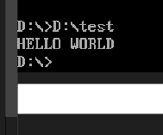

In this task, I made 11 modules to print 1 character each.

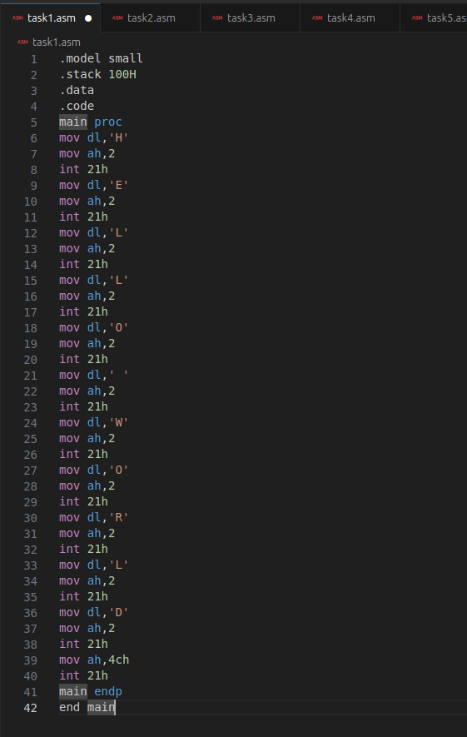

Task2:
Write Assembly program to Input Character from user and display it.
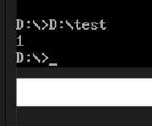

In this task, I took one character input from user using 01 schedule which echoes it’s data (saved in register) onto the output screen.
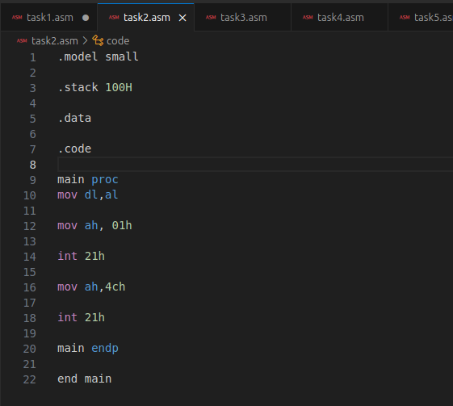

Task3:
Take number and print the next number

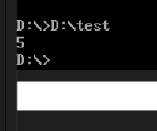

In this task, I took a number as input from user and incremented in it using inc.
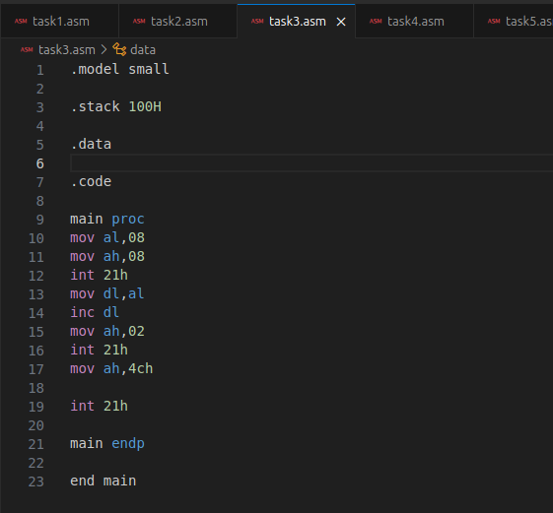

Task4:
Take a number and print the previous number
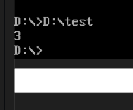

In this task, I took a number as input from user and decremented it using dec.
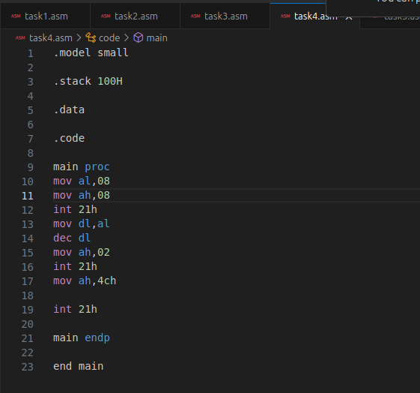

Task5:
Write Assembly program to Input Lower Case letter from user and display it’s upper case. (Subtract 32 in ASCII)
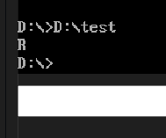

In this task, I took a lowercase input from user and subtracted 32 from it before displaying it again.
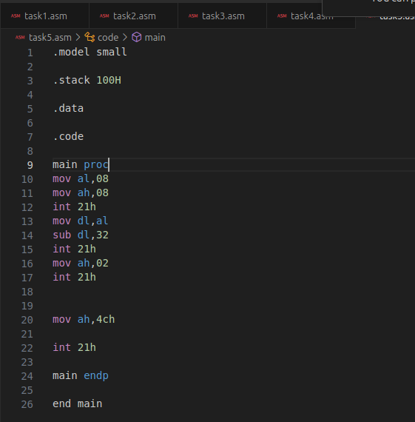

Task6:
Write Assembly program to Input Upper Case letter from user and display it’s lower case. (ADD 32 from ASCII)
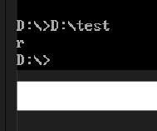

In this task, I took an uppercase character as input from user and added 32 to it to convert it into lowercase.
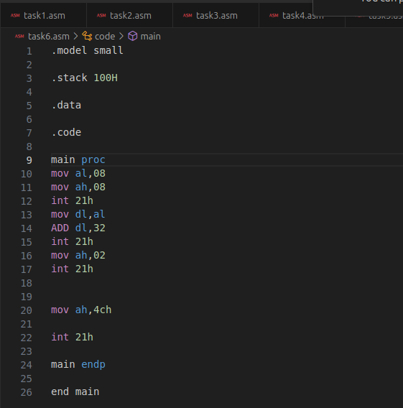

Task7:
Write Assembly program to input letter from the user and display the next character
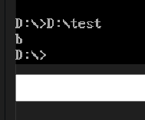

In this task, I took an input from user and incremented the input by 1 which changes the input to the next character.
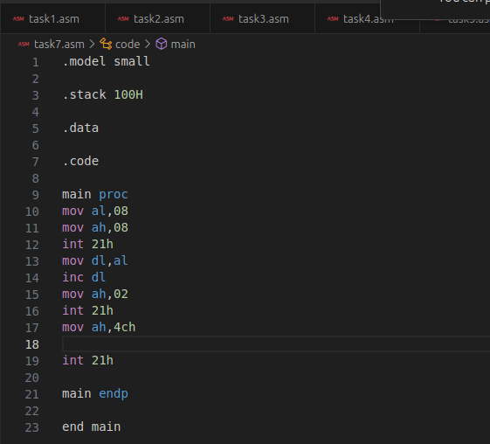

Task8:
Write an assembly language program to ADD two values.
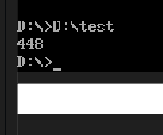

In this task, I took a value from user, stored it in the base register, took another input from user and updated the value stored in the accumulator register before displaying it again. I also added and subtracted 30h to not let the ASCII value get added.
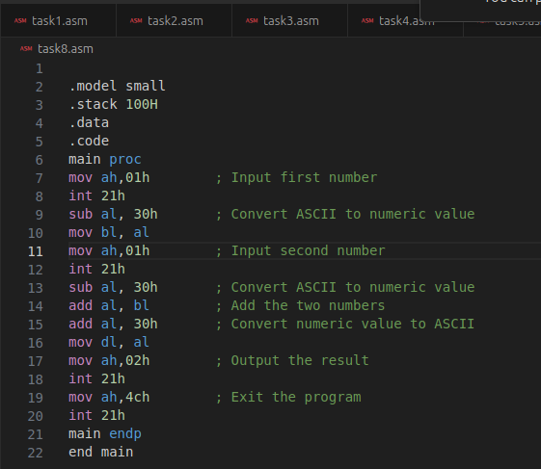

Task9:
Write an assembly language program to subtract two values.
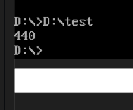

In this task, I took a value from user, stored it in the base register, took another input from user and updated the value stored in the accumulator register before displaying it again. I also added and subtracted 30h to not let the ASCII value get subtracted.
